Case 10-AM,S-Ecuador-Valdivia-Palmer Notched Figurines Phase II-2600 BCE

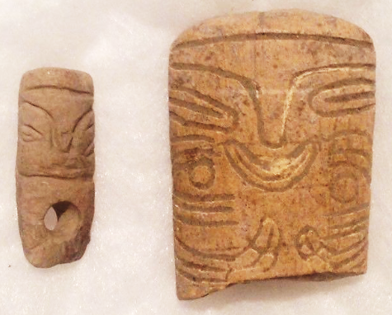 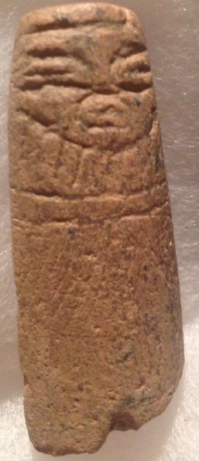 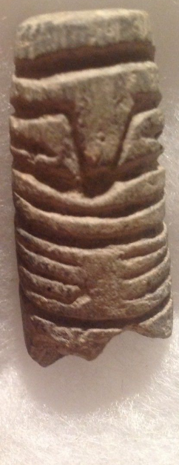

Figs. 1-4: Ecuador-Valdivia-Palmer notched Anthropomorphic Stone Figurines Phase I

-2600-2400 BCE. Fig. 1. Face design (cap, eyes nose, mouth and chin) with conically drilled hole for suspension; Fig. 2. Face design (cap, eyes nose, mouth face tattoos of three stripes and circles) with a three-tine rake-like design for hands and three parallel curving upwards lines for feet; Fig. 3. Face design (cap, eyes nose, mouth and chin); Fig. 4. Face design (cap, eyes nose, mouth and chin) with a three-tine rake-like design for hands.

**Case no.:**

**Accession Number:**

**Formal Label:** Ecuador-Valdivia-Palmer Notched Anthropomorphic Stone Figurines Phase II

-2600-2400 BCE

**Display Description:**

Valdivia Palmer-notched Anthropomorphic Stone Figurines are the earliest known human figurines in the New World. Palmer figurines evolved from simple rectangular plaques with a groove indicating the division between the legs but no head.

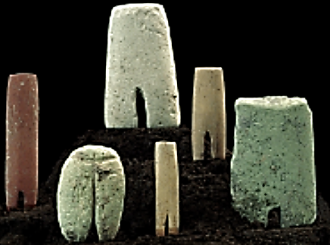

Palmer-notched Anthropomorphic Stone Figurines, Phase I, 3500-2600 BCE. After http://www.galeriacontici.net/wpimages/wp2578da64_06.png

Palmer notched Anthropomorphic Stone Figurines Phase II (2600-2400 BCE) above, expanded the stone prisms vertically adding facial features denoting caps, eyes, noses and mouths and depicted hands as three-tine, rake-like designs.

**LC Classification:**

**Date or Time Horizon:**

**Geographical Area:**

**Map:**

**GPS coordinates:**

**Cultural Affiliation:**

**Media:**

**Dimensions:**

**Weight:**

**Condition:**

**Provenance:** Ex. B. Burns Collection New York, NY

**Discussion:**

**References:**

Similar examples published in Ancient Ecuador - Culture, Clay and Creativity 3000-300 B.C. Also appear at Casa del Alabado Museum of Pre-Columbian Art, Quito, Ecuador.

Appendix:

